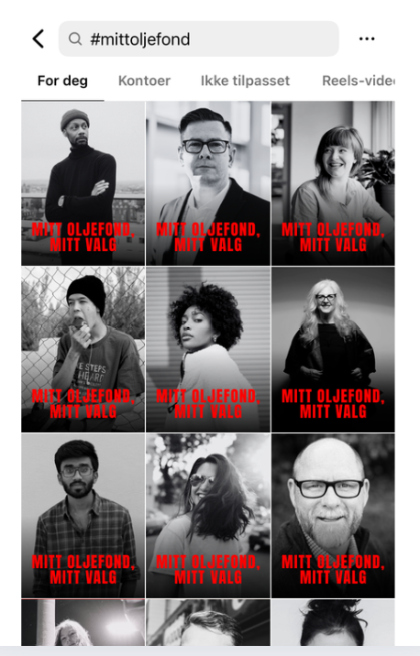
The situation in Gaza and the West Bank is catastrophic! Situasjonen i Gaza og på Vestbredden er katastrofal!
LO has voted in favor of a boycott of Israel, and over 50 organizations are calling on Jens Stoltenberg to withdraw the oil fund from companies that contribute to the occupation and genocide.
A recent poll also shows that 8 out of 10 Norwegians believe the oil fund should pull out of companies involved in human rights violations.

Now we must show our elected officials that we, the people, are serious. Inspired by #ispeakupforpalestine, we are launching the campaign #mittoljefond- my choice.

We need you to help bring more people on board! ❤️
Heres how to join:
1️⃣ Choose a serious or neutral black-and-white photo of yourself.
2️⃣ Download this PNG file to overlay on your photo:
https://drive.google.com/file/d/1L4r56H_Fawxz6I3rUscA4xsCGdpKVG-f/view?
Or:
2️⃣ Insert your photo into this Canva template:
https://www.canva.com/design/DAGmmuGgK4U/w3-vjcHq-EwbNgnOj0CUrw/edit
(Canva works on mobile, bu tits a bit easier on desktop)
3️⃣ Share your image on Instagram (and preferably Facebook too).
Use the text below- or your own words:
I cannot live with Norway being on the wrong side of history.
We cannot have an oil fund invested in occupation, financing breaches of international law and genocide.
I support the demand to divest the oil fund from the Israeli occupation NOW!
My oil fund, my choice. My share will NOT support illegal occupation.
#mittoljefond
Do you agree? Create your own post!And don’t forget to tag @jensstoltenberg, @regjeringen, and @stortinget. You’ll find a list of the Finance Committee members at the bottom of the document.

Want to do more? 🎥
Create a short black-and-white video. Say something like this:
Dear elected officials:
A genocide is being carried out against the Palestinian people.
We cannot have a Oil Fund invested in illegal occupation.
You represent me in Parliament.
Get the Oil Fund out of the occupation!
My Oil Fund, my choice.
Can’t get Canva or the PNG to work? No worries!
Heres how to create the post directly in Instagram:
1️⃣ Choose a black-and-white photo of yourself (use a filter in the app).
2️⃣ Add this text using the “Classic” font, centered:
MITT OLJEFOND,
MITT VALG
🔴 Use red text color (first red on the second swipe in the color picker)
🔠 Make the text large enough that «MITT OLJEFOND» just fits o none line
📍 Place the text in the center of the image, with the bottom of the text “resting” on the trash can lid icon (in layout view)
👉 Use the same caption as before
👉 Dont forget the hashtag: #mittoljefond
Examples:
Made in Canva (left) and Instagram (right)
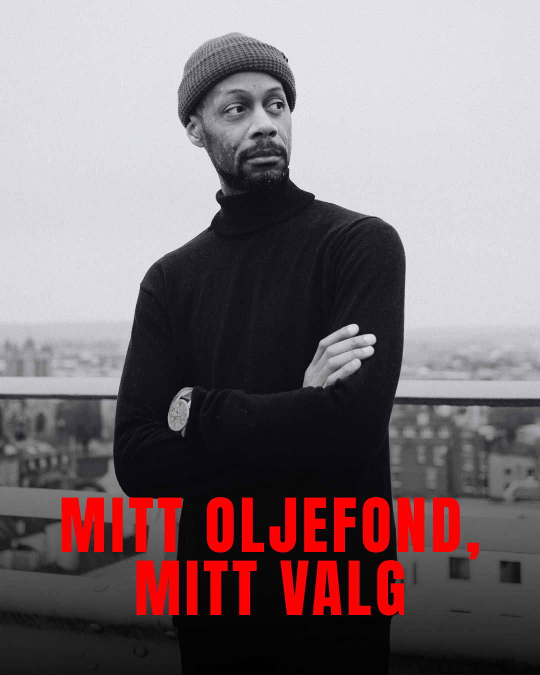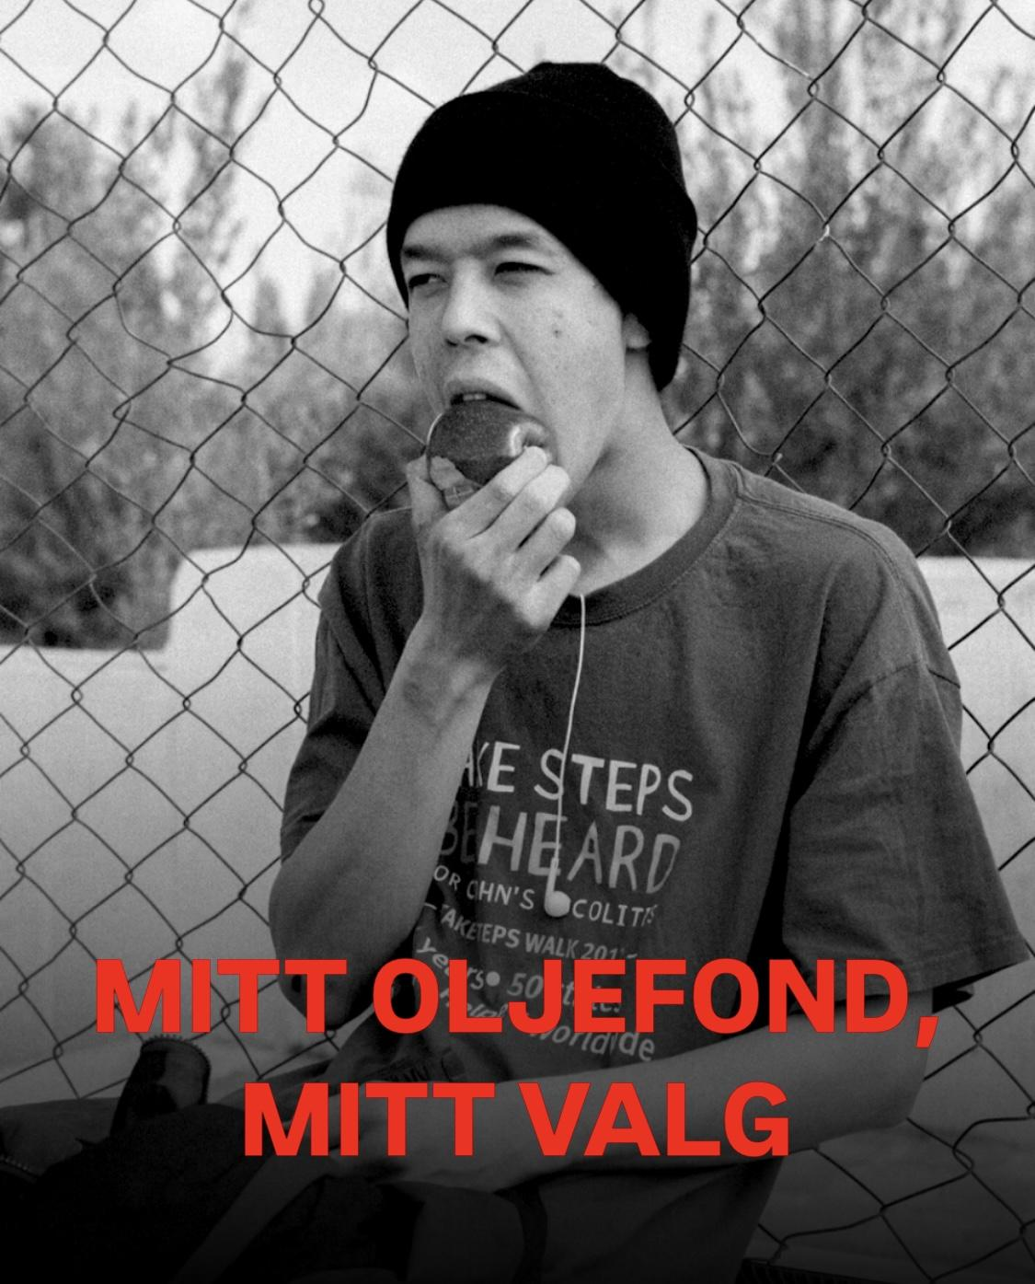
This is what it looks like when we are many:

Members of the Finance Committee:
Navn | Parti | Insta
Moflag, Tuva | A | tuvamoflag
Bru, Tina | H | hoyretina
Berg, Lan Marie Nguyen (Har permisjon, Heiberg, Sigrid Zurbuchen møter som vararepresentant) | MDG | lanmaries / sigridzh
Farahmand, Mahmoud | H | mfarahmand79
Knutsen, Eigil | A | eigilknutsen
Limi, Hans Andreas | FrP
Lunde, Heidi Nordby | H | heidinlunde
Martinussen, Marie Sneve | R | marie_sneve
Mehl, Emilie | Sp | emiliemehl
Myhrvold, Ole André | Sp | oamyhrvold
Mørland, Tellef Inge | A | tellefmorland
Orten, Helge | H | helgeorten
Pollestad, Geir | Sp | geirpollestad
Ropstad, Kjell Ingolf | KrF | kjellingolf
Rotevatn, Sveinung | V | sveinungrotevatn
Skjæran, Bjørnar | A | bjornarskjaeran
Steffensen, Roy | FrP | spursroy
Unneland, Andreas Sjalg | SV | andreasunneland
Aasen-Svensrud, Maria | A | mariaaasensvensrud
Aasrud, Rigmor | A | rigmorap

